

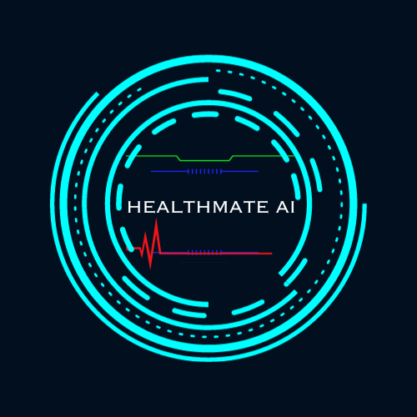

**Team Members: Accepted by: Marildo Cani Dr.Igli Hakrama**

**Sefer Lekloti**

**Armand Kala**

**Table Of Contents**

1. **Introduction____________________________________**

**1.1**  **A Visionary Journey______________________________________**

**1.2 Bridging Gaps in Healthcare_______________________________**

**1.3 Navigating the Narrative_________________________________**

**2.** **HealthMate AI Overview__________________________**

**1.1 Post-Operations Support_________________________________**

**1.2 AI-Powered Communication______________________________**

**1.3 Hospital Staff Interaction_________________________________**

**1.4 Segment for Individuals__________________________________**

**1.5 Key Features___________________________________________**

**1.5.1 User Registration and Profile Dashbord______________**

**1.5.2 Health Metrics Input_____________________________**

**1.5.3 AI Communication_______________________________**

**1.5.4 Appointment Scheduling___________________________**

**1.5.5 Hospital Staff Communication______________________**

**3. Scope ______________________________­­­­­­­_____________**

**3.1.1 Post-Operative Health Management______________________**

**3.1.2 Health Metrics Tracking________________________________**

**3.1.3 AI-Driven Recomandations_______________________________**

**3.1.4 Direct Communication Channels__________________________**

**3.1.5 Hospital Staff Collaboration______________________________**

**3.1.6 Usability for Hsopital Patients and General Users____________**

**4. Requirements____________________________________**

**4.1 Functional Requiremnets______________________________________**

**4.1.1 User Requiremnets_____________________________________**

**4.1.2 System Requirements___________________________________**

**4.2 Nonfunctional Requirements____________________________________**

**4.3 External Requirements_________________________________________**

**5. StakeHolders_____________________________________**

**6.Scenarios________________________________________**

**7. Use Cases________________________________________**

**7.1 User______________________________________________________**

**7.2 Profile Management_________________________________________**

**7.3 Health Monitoring__________________________________________**

**7.4 Communication with AI _____________________________________  
 7.5 AI Recommandations_______________________________________**

**7.6 Appointment Scheduling____________________________________**

**7.7 Hospital Administration____________________________________**

**7.8 Health Care Providers______________________________________**

**7.9 IT Team__________________________________________________**

**7.10 Sales and Marketing Team _________________________________**

**7.11 Costumer Support_________________________________________**

**7.12Individuals(non-patients)____________________________________**

**7.13** **Regulatory Authorities_____________________________________**

**7.14 Developers_____________________________________________**

**8. BPMN________________________________________**

**9. Activity Diagram________________________________**

**10. State Diagram__________________________________**

**11. Collaboration Diagram___________________________**

**12. Sequence Diagram___________________________**

**DFD Diagram__________________________________**

**13. Class Diagram________________________________**

**13.1 User__________________________________________________**

**13.2 Health Mtrics___________________________________________**

**13.4 AI – Assistant_________________________________________**

**13.5 Hospital Staff_________________________________________**

**13.6 Database_____________________________________________**

**13.7 Appointment_________________________________________**

**13.8 Non Patient Segment_________________________________**

**14. Factory method Design Pattern_________________**

**15. Abstract Design Pattern_______________________**

**16. Proxy Design Pattern(Diagram of Sequence) ______**

**17. Object Diagram_______________________________**

**18. Package Diagram______________________________**

**19. Components_________________________________**

**20. Deployement_________________________________**

**1. Introduction**

Welcome to the world of HealthMate AI – a revolutionary application designed to transform healthcare experiences. In the realm of digital health, innovation knows no bounds, and HealthMate AI stands as a testament to the endless possibilities that technology brings to our lives.

**1.1 A Visionary Journey**

Embark on a visionary journey where healthcare transcends traditional boundaries. Imagine a world where individuals have the power to manage their well-being seamlessly, with the support of cutting-edge technology. HealthMate AI is not just an application; it's a companion on your health and wellness expedition.

**1.2 Bridging Gaps in Healthcare**

Healthcare is a complex landscape, often marred by inefficiencies and gaps. HealthMate AI emerges as a bridge, connecting users with personalized, intelligent solutions. From post-operative care to proactive health management, this application is poised to redefine how we approach our well-being.

**1.3 Navigating the Narrative**

As you delve into the pages of this documentation, anticipate an exploration of HealthMate AI's features, functionalities, and the underlying technology. Discover how the application seamlessly integrates into the lives of users, offering a holistic approach to health management.

1. **HealthMate AI Overview**

HealthMate AI is an innovative healthcare application tailored for hospitals to enhance the post-treatment care and well-being of their patients. The application operates in three distinct stages, each contributing to the seamless management of a patient's health and recovery.

* 1. **Post-Operation Support:**
  + After undergoing a medical procedure, users can leverage the application to access information about the post-operative phase.
  + Users can inquire about normal post-operative experiences, receive recommendations, and gain insights into managing their recovery.
  1. **AI-Powered Communication:**

In scenarios where users cannot find solutions through the application's resources, they can engage in direct communication with the AI intelligence embedded in the system.

Communication can occur through text, allowing users to describe symptoms or send images for assessment.

The AI responds with relevant suggestions based on the provided information.

* 1. **Hospital Staff Interaction:**

If users' conditions persist despite AI recommendations, they automatically progress to direct communication with the hospital's staff.

Users can establish real-time communication with hospital personnel, receiving personalized recommendations and, if necessary, being directed to the hospital for immediate treatment.

* 1. **Segment for Individuals:**

The application also features a segment for individuals who are not current patients. This segment is fee-based, and users can access various health-related features.

For patients, the service remains free until their treatment concludes. Afterward, a nominal monthly fee applies, allowing continued access to the application's services as a health management tool.

* 1. **Key Features**

**1.5.1 User Registration and Profile Dashboard:** Users can register within the application and access a personalized profile dashboard.

**1.5.2 Health Metrics Input:** Users actively contribute to their well-being by recording weight, blood pressure, heart rate, and specific symptoms. This personalized health data informs AI algorithms, facilitating tailored recommendations and proactive health guidance.

This innovative approach empowers users to actively participate in their health journey, ensuring personalized and effective health management through the integration of advanced technologies and user-driven input.

* + 1. **AI Communication:** The application facilitates communication with an AI assistant, which processes user input and generates personalized recommendations.
    2. **Appointment Scheduling:** Users can schedule appointments through the application, checking availability and confirming appointments.
    3. **Hospital Staff Communication:** Direct communication with hospital staff is enabled, ensuring users receive timely and tailored medical advice.

**3. Scope**

**3.1 Scope:**

The scope of the HealthMate AI project encompasses:

* + 1. **Post-Operative Health Management:**
  + Focused on providing a holistic solution for individuals recovering from surgeries, helping them navigate the post-operative phase with personalized support.

**3.1.2 Health Metrics Tracking:**

* + Inclusion of features for users to input and track health metrics such as weight, blood pressure, heart rate, and specific symptoms.

**3.1.3 AI-Driven Recommendations:**

* + Implementation of an intelligent AI assistant to analyze user input and generate tailored health recommendations.
    1. **Direct Communication Channels:**
  + Establishment of communication pathways for users to interact directly with the AI assistant and, if needed, with healthcare professionals.
    1. **Hospital Staff Collaboration:**

Integration to enable seamless communication between users and hospital staff, ensuring prompt responses and assistance.

**3.1.6 Usability for Hospital Patients and General Users:**

* 1. Tailoring the application to meet the needs of hospital patients while offering a segment for general users interested in health management.

**4. Requirements**

**Functional Requirements:**

**User Requirements:**

User Registration:

* + Users should be able to register on the HealthMate AI platform.
  + Collect essential information during registration, including full name, date of birth, contact details, and communication preferences.
  + Implement secure authentication, such as two-factor authentication.

Profile Management:

* + Users should have a comprehensive profile dashboard.
  + The profile should include sections for medical history, allergies, medications, and emergency contact details.
  + Allow users to set notification preferences and customize their user interface.

Health Monitoring:

* + Develop an intuitive interface for users to input and track health metrics.
  + Include categories like vital signs, medication adherence, and general well-being.
  + Provide visualizations and trends over time for monitoring.

Communication with AI:

* + Implement a natural language processing (NLP) system for user-AI communication.
  + Support both text and image input for symptom descriptions.
  + Ensure prompt AI responses with clear explanations.

AI Recommendations:

* + The AI module should analyze user input and health data to generate personalized recommendations.
  + Recommendations may include actions, lifestyle changes, or alerts.
  + Ensure transparency in the AI's reasoning process.

Appointment Scheduling:

* + Integrate a user-friendly appointment scheduling system.
  + Allow users to book appointments with healthcare professionals.
  + Include features like reminders and appointment history.

**System Requirements:**

Security and Privacy:

* + Implement robust encryption for data security.
  + Adhere to industry data protection standards (e.g., GDPR, HIPAA).
  + Conduct regular security audits and vulnerability assessments.

Scalability:

* + Design scalable system architecture.
  + Utilize cloud-based solutions for flexibility.
  + Optimize databases and load balancing for growth.

Cross-Platform Compatibility:

* + Develop responsive interfaces for various devices and platforms.
  + Prioritize mobile responsiveness.
  + Consider cross-platform frameworks like React Native or Flutter.

Data Storage and Retrieval:

* + Implement a secure and efficient database system.
  + Optimize data retrieval mechanisms for real-time access.

AI Integration:

* + Establish a reliable API connection with the AI module.
  + Facilitate real-time data exchange with AI.
  + Ensure modular AI for future updates.

**Nonfunctional Requirements:**

Performance:

* + Response time within 2 seconds.
  + Handle at least 10,000 concurrent users without performance degradation.

Reliability:

* + Aim for 99.9% uptime.
  + Implement robust error handling.

Security:

* + Encrypt sensitive user data.
  + Implement secure authentication and authorization.
  + Comply with data protection regulations.

Usability:

* + Ensure an intuitive user interface.
  + Support accessibility standards.

Scalability:

* + Accommodate 20% new users per month.
  + Efficiently handle growing data volume.

Compatibility:

* + Support popular web browsers and mobile platforms.
  + Ensure functionality across various devices.

Maintainability:

* + Maintain a modular architecture.
  + Provide comprehensive documentation.

Regulatory Compliance:

* + Adhere to healthcare standards.
  + Conduct regular security audits and compliance checks.

Interoperability:

* + Facilitate integration with external healthcare systems.
  + Follow industry-standard API protocols.

Collaboration:

* + Maintain open communication with the client.
  + Involve stakeholders in testing and validation

**External Requirements:**

**-Collaboration with Healthcare Professionals:**

Engage with healthcare professionals (e.g., doctors, nurses, medical experts) for validation and feedback.

Ensure that AI-generated health recommendations align with medical best practices.

Involve healthcare professionals in the assessment of recommendations.

**-Collaboration with End-Users:**

Involve end-users of the HealthMate AI platform in testing and feedback.

Gather insights on the user experience, preferences, and usability.

Use feedback to refine the platform for a user-friendly experience.

**5. StakeHolders**

|  |  |  |  |  |  |  |
| --- | --- | --- | --- | --- | --- | --- |
| **Stakeholder Name** | **Role/Responsibility** | **Importance** | **Influence** | **Positive Impacts/Interests** | **Concerns** | **Communication Needs** |
| *Hospital Administrators* | Management of the Hospital | High | High | Improved patient care, efficiency, and satisfaction | Data security and privacy, system reliability | Regular updates on system performance, feedback on patient satisfaction |
| *Healthcare Providers* | Doctors, Nurses | High | High | Enhanced patient outcomes, reduced readmissions, compliance | System usability, accuracy of AI recommendations | Access to patient data, AI recommendations, channels for direct communication with patients |
| *Patients* | Individuals receiving care | High | Low/Medium | Personalized and timely healthcare support | Privacy of personal health information, system reliability | Access to AI recommendations, ability to communicate symptoms/concerns, seamless transition between stages of care |
| *IT Team* | IT Specialists, Developers | Medium | High | System functionality, security, and data privacy | Technical challenges, system scalability | Technical updates, system maintenance, feedback on user experience and system performance |
| *Sales and Marketing Team* | Sales and Marketing Professionals | Medium | Medium | User acquisition, subscription growth | User retention, market competition | User feedback, marketing strategies, feedback on subscription offerings and pricing models |
| *Customer Support* | Customer Service Representatives | Medium | Medium | Addressing user inquiries, technical support | User feedback, system downtime | User feedback, technical support, reporting system issues/bugs |
| *Individuals (Non-Patients*) | Potential Users | Low | Low | Access to fee-based service and potential future patients | Perceived value of the service, cost concerns | Marketing and promotional efforts, user feedback on service experience |
| *Regulatory Authorities* | Government Bodies, Compliance Officers | High | High | Ensuring compliance with healthcare regulations and standards | Regulatory changes, potential legal implications | Updates on compliance requirements and potential changes in regulations affecting the application |

**6. SCENARIOS**

**Scenario 1: Post-Operative Support**

**User:** Emily, a patient recovering from knee surgery.

1. **Initiation:**
   * Emily logs into the HealthMate AI application.
   * She navigates to the "Post-Operative Support" section.
2. **Interaction with AI:**
   * Emily inputs her symptoms and recovery concerns through text and images.
   * The AI processes the information and provides personalized recommendations for managing post-operative experiences.
3. **Hospital Staff Interaction:**
   * If Emily's condition persists, the AI escalates the issue, and she engages in real-time communication with hospital staff.
   * Hospital staff provides personalized recommendations, ensuring a seamless recovery process.

**Scenario 2: Health Metrics Tracking**

**User:** James, a fitness enthusiast monitoring his health.

1. **User Registration:**
   * James registers on the HealthMate AI platform, creating a personalized profile.
2. **Health Metrics Input:**
   * He actively records weight, blood pressure, heart rate, and specific symptoms through the application.
3. **AI-Driven Recommendations:**
   * The AI processes James's health metrics, offering tailored recommendations for lifestyle changes and proactive health management.

**Scenario 3: Appointment Scheduling**

**User:** Sarah, a patient requiring a follow-up appointment.

1. **Accessing Profile Dashboard:**
   * Sarah accesses her profile dashboard.
2. **Appointment Scheduling:**
   * She navigates to the "Appointment Scheduling" feature.
   * Checks the availability and schedules a follow-up appointment directly through the application.
3. **Confirmation and Reminders:**
   * HealthMate AI confirms the appointment and sends reminders to Sarah.

**Scenario 4: Hospital Staff Communication**

**User:** Alex, a patient seeking immediate medical advice.

1. **Communication with AI:**
   * Alex communicates with the AI, describing urgent symptoms through text.
2. **Direct Communication with Hospital Staff:**
   * The AI, recognizing the urgency, connects Alex directly with hospital staff.
   * Hospital staff offers immediate assistance and directs Alex to the hospital if necessary.

**7. USE CASES**

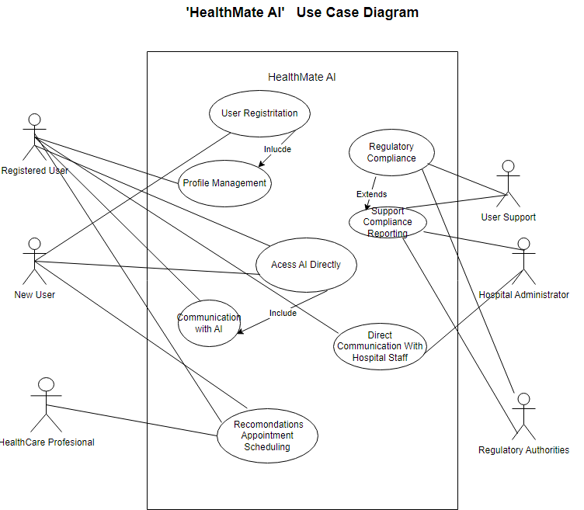

**7.1 User Registration**

**Actors:** New User

Description: New users can initiate the registration process by providing essential information such as full name, date of birth, contact details (email, phone), and preferred communication methods (push notifications, emails). The system verifies the information and creates a secure user account.

**7.2 Profile Management:**

**Actors:** Registered User

Description: Registered users can access a comprehensive profile dashboard to manage personal information and preferences. The profile includes sections for medical history, allergies, current medications, and emergency contact details. Users can set notification preferences and customize the user interface for a personalized experience.

**7.3 Health Monitoring:**

**Actors:** Registered User

Description: Users can input and track various health metrics through an intuitive interface. Categories include post-operative symptoms, vital signs, medication adherence, and general well-being. The system provides visualizations and trends over time to help users monitor their health progress effectively. Users can receive reminders to input health data.

**7.4 Communication with AI:**

**Actors**: Registered User

Description: Users can communicate directly with the AI using natural language processing (NLP). They can describe symptoms, ask questions, and even send images for assessment. The AI responds promptly, offering clear explanations and providing relevant information or recommendations based on the user's input.

**7.5 AI Recommendations:**

**Actors:** Registered User

Description: The AI module analyzes user input, health data, and historical information to generate personalized recommendations. Recommendations may include suggested actions, lifestyle changes, or alerts for potential health issues. The AI's reasoning process is transparent, and users can view detailed explanations behind each recommendation.

**7.6 Appointment Scheduling:**

**Actors:** Registered User, Healthcare Professional

Description: Users can schedule appointments with healthcare professionals directly through the application. The system offers a user-friendly interface, allowing users to view available time slots, book appointments, and receive confirmation. Features include appointment reminders, rescheduling options, and a history of past appointments.

**7.7 Hospital Administration:**

**Actors:** Hospital Administrator

Description: Hospital administrators can oversee the implementation and use of the HealthMate AI application within the hospital. They may provide input on system requirements, monitor usage, and ensure alignment with hospital policies.

**7.9 Healthcare Providers:**

**Actors:** Healthcare Providers

Description: Healthcare providers (doctors, nurses, etc.) utilize the application for appointment scheduling, viewing patient data, and providing recommendations. They interact with patient health information to deliver personalized healthcare services.

**7.10 IT Team:**

**Actors:** IT Team

Description: The IT team manages the technical aspects of the HealthMate AI system, including development, deployment, and maintenance. They implement system updates, ensure data security, and address technical issues.

**7.11 Sales and Marketing Team:**

**Actors:** Sales & Marketing

Description: The sales and marketing team promotes the HealthMate AI application, engages with potential users, and contributes to user acquisition. They provide insights on user needs, feedback from the market, and contribute to the application's market positioning.

**7.12 Customer Support:**

**Actors:** Customer Support

Description: Customer support provides assistance to users, addressing queries, issues, and ensuring a positive user experience. They respond to user inquiries, resolve issues, and provide feedback to the IT team.

**7.13 Individuals (Non-Patients):**

**Actors:** Individuals

Description: Individuals who are not currently patients but use the application for general health inquiries. They may communicate with the AI, schedule appointments, and use the application for health-related information.

**7.14 Regulatory Authorities:**

**Actors**: Regulatory Authorities

Description: Regulatory authorities ensure that the HealthMate AI application complies with relevant healthcare regulations and standards. They may provide guidelines and conduct assessments to ensure legal and ethical use.

**7.15 Developers:**

**Actors:** Developers

Description: The development team is responsible for designing, developing, and maintaining the HealthMate AI application. They implement system updates, address technical issues, and collaborate with stakeholders.

**8. BPMN Diagram**

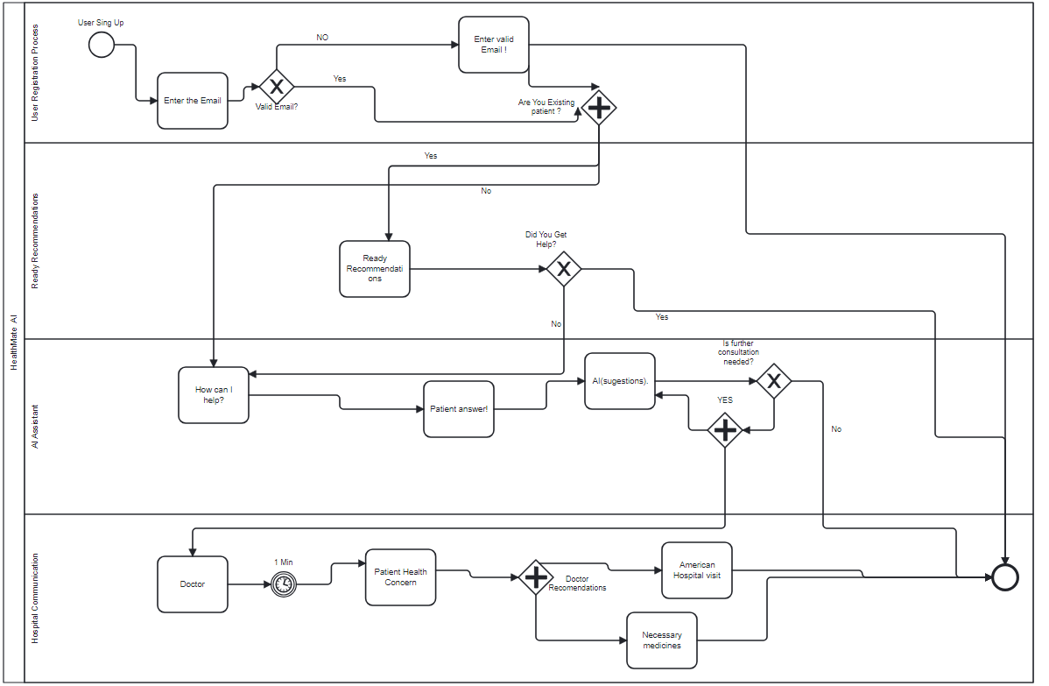

**9. Acitivity Diagram**

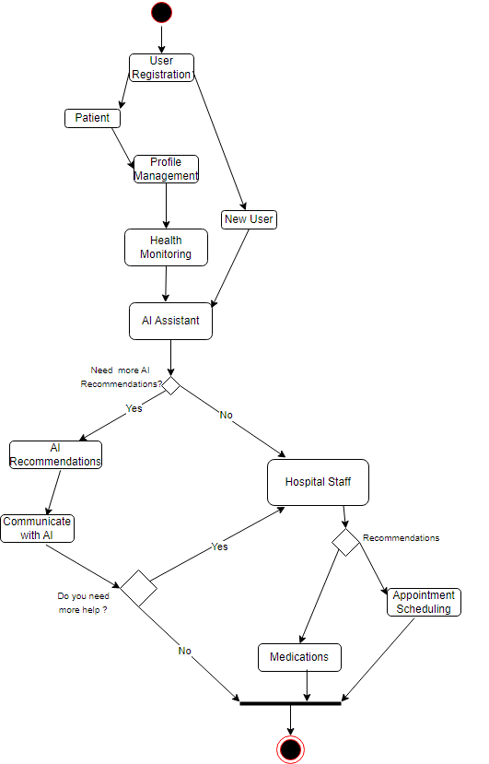

**Initiate Registration:**

--User starts the registration process to create an account.

--System verifies user information and creates a secure account.

**Access Profile Dashboard:**

--Registered users access their comprehensive profile dashboard.

--Users can visualize health metrics, input data, and set preferences.

**Input Health Metrics:**

--Users input various health metrics through an intuitive interface.

--The system provides visualizations and trends over time.

**Remind User:**

--The system sends reminders to users to input health data regularly.

**Communicate with AI:**

--Users communicate directly with the AI using natural language processing (NLP).

--Users describe symptoms, ask questions, and receive relevant information.

**View AI Recommendations:**

--Users receive personalized recommendations generated by the AI.

--Recommendations may include suggested actions, lifestyle changes, or health alerts.

**Schedule Appointment:**

--Users can schedule appointments with healthcare professionals.

--The system offers a user-friendly interface for appointment management.

**View Appointments:**

--Users view their scheduled appointments.

--Healthcare professionals can also view and confirm appointments.

**Confirm Appointment**:

--Users confirm scheduled appointments with healthcare professionals.

**Interact with Patients:**

--Healthcare professionals interact with patients directly through the application.

--Healthcare professionals deliver healthcare services based on patient needs.

**Deliver Healthcare Services:**

--Healthcare professionals provide necessary services and recommendations.

**Manage Technical Aspects**:

--The IT team manages technical aspects, implements updates, and addresses technical issues.

**Promote Application:**

--The sales and marketing team promotes the HealthMate AI application.

**Provide Assistance:**

--The customer support team provides assistance, resolves issues, and offers feedback.

**Use Application for Inquiries:**

--Individuals use the application for inquiries, communicate with the AI, and schedule appointments.

**10. State Diagram**

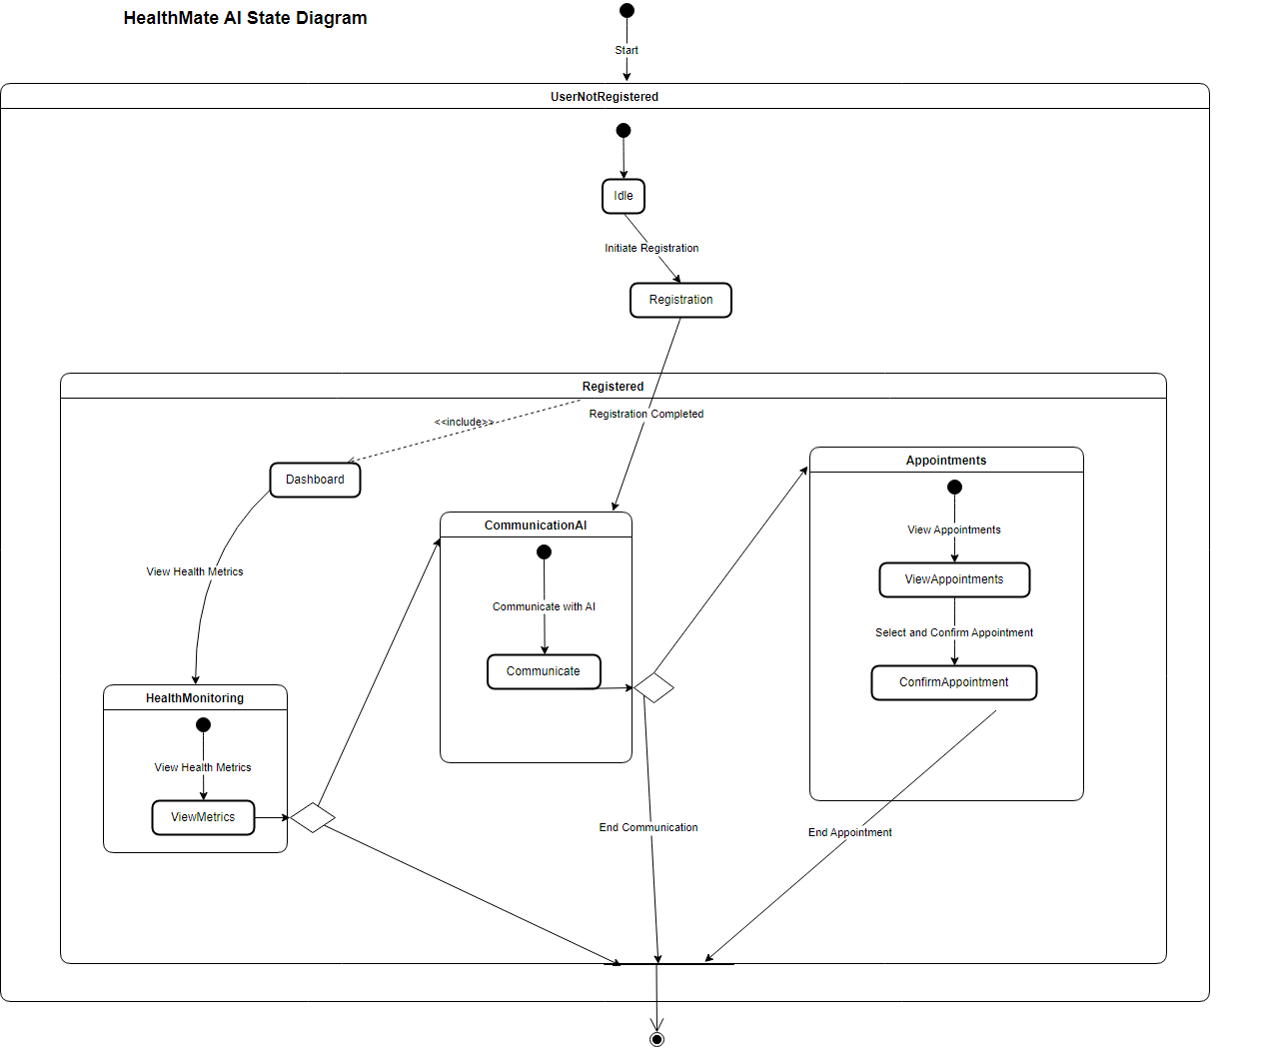

The HealthMate AI state diagram outlines the dynamic states and transitions within the application. It visualizes the progression of user interactions from the initial state to final states, incorporating key functionalities for user registration, profile management, health monitoring, communication with AI, and appointment scheduling.

**--UserNotRegistered**

Idle: The starting point of the application.

Registration: Transition initiated upon user registration, leading to the Registered state upon completion.

**--Registered**

Dashboard: Access to the user's profile dashboard for comprehensive management.

HealthMonitoring: Visualization of health metrics with the option to transition based on user decisions.

CommunicationAI: Communication with AI for personalized assistance, including the option to inquire about appointments.

Appointments: Scheduling appointments with healthcare professionals.

**--HealthMonitoring**

ViewMetrics: Monitoring health metrics with the option to conclude or transition to further AI communication.

**--CommunicationAI**

Communicate: Direct interaction with the AI for health-related inquiries, including the option to inquire about appointments.

End Communication: Conclusion of the AI interaction.

**--Appointments**

ViewAppointments: Viewing scheduled appointments.

ConfirmAppointment: Confirming scheduled appointments.

End Appointment: Conclusion of the appointment scheduling process.

**--End :** Final state indicating the completion of the user's interaction with the application.

**11. Collaboration Diagram**

The HealthMate AI Collaboration Diagram delineates the orchestrated interaction flow within the application. This visual representation encapsulates the dynamic engagement among key components, including the User, HealthMateAI, Database, AIAssistant, and HospitalStaff. The sequence of actions reflects the user-centric design and seamless communication channels integrated into HealthMate AI:

**---- User-HealthMate AI**

1. **Initialize Application:** Users commence their journey by initializing the application, marking the initiation of the user experience.
2. **Register:** The registration process securely stores user data in the Database, ensuring a seamless and confirmed registration.
3. **Access Profile Dashboard:** Users navigate through their personalized dashboards, facilitating comprehensive health monitoring.
4. **Input Health Metrics:** Precise health data input is recorded and confirmed in the Database, enriching the user profile.
5. **Communicate with AI:** Direct communication with the AIAssistant offers users personalized interaction and support.
6. **Generate Recommendations:** The AIAssistant processes user input, providing tailored health recommendations promptly displayed to the user.
7. **Schedule Appointment:** Seamless appointment scheduling involves confirmation through the Database, ensuring user convenience.
8. **Communicate with Hospital Staff:** Direct channels with HospitalStaff enable users to interact for personalized assistance and care.
9. **Conclude Interaction:** Users efficiently conclude interactions, showcasing the streamlined and user-friendly nature of HealthMate AI.

**HMA- Database**

1. Save User information
2. Confirmation
3. Save Health Metrics
4. Confirmations
5. Check Availability

**HMA – AI Assistant**

1. Process User Input
2. Generate Recommendations

**HMA-Hospital Staff**

1. Request Communication
2. Respond to User

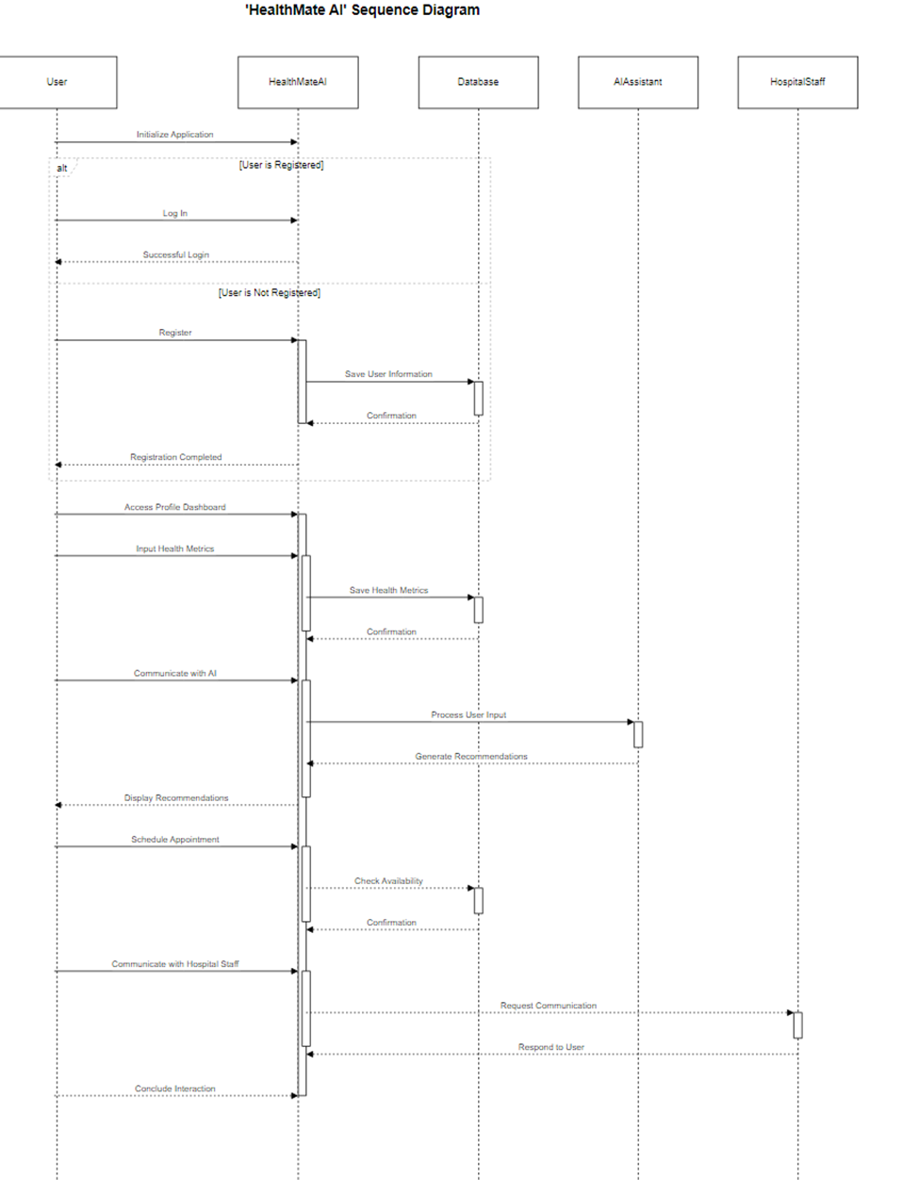**12. Sequence Diagram**

**Participants:**

* **User:** Represents the end-user interacting with the HealthMate AI system.
* **HealthMate AI:** Central system orchestrating interactions and providing various services.
* **Database:** Stores and retrieves user and health-related information.
* **AI Assistant:** Module within HealthMate AI processing user input and generating recommendations.
* **Hospital Staff:** External entity the user might interact with through HealthMate AI.

**Scenario: User Registration and Interaction**

1. **Initialize Application:**
   * User initiates the HealthMate AI application.
   * HealthMate AI activates to handle user interactions.
2. **User Registration:**
   * Depending on whether the user is registered or not:
     + If registered, the user logs in, and a successful login message is exchanged.
     + If not registered, the user goes through the registration process:
       - User provides registration details.
       - HealthMate AI saves user information in the database.
       - Confirmation is sent back to the user.
3. **Access Profile Dashboard:**
   * User accesses the profile dashboard within HealthMate AI.
4. **Input Health Metrics:**
   * User inputs health metrics, and HealthMate AI stores the data in the database.
5. **Communicate with AI:**
6. **Schedule Appointment:**

**DFD diagram**

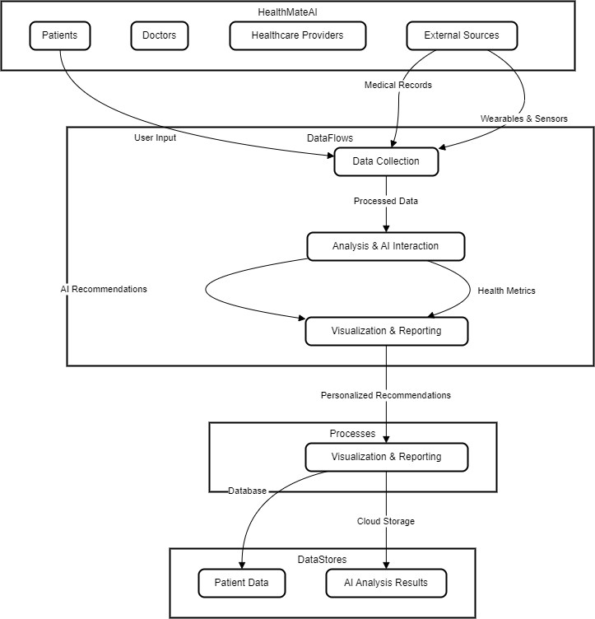

The HealthMate AI Data Flow Diagram (DFD) provides a detailed overview of the system's functionality, illustrating the seamless flow of data through various processes to deliver a comprehensive healthcare management solution.

**System Context:**

* **Users:**
  + Patients
  + Doctors
  + Healthcare Providers
  + External Sources
* **Data Flows:**
  + **User Input & Data Collection:**
    - Patients contribute health metrics.
    - External sources provide medical records and sensor data.
  + **Analysis & AI Interaction:**
    - Data undergoes analysis for insights.
    - AI generates personalized recommendations.
  + **Visualization & Reporting:**
    - Health insights are visualized.
    - Reporting for patients, doctors, and healthcare providers.
* **Processes:**
  + **Data Collection:**
    - Aggregates user input and external data.
  + **Analysis & AI Interaction:**
    - Applies algorithms to analyze health data.
    - Engages with the AI for personalized recommendations.
  + **Visualization & Reporting:**
    - Transforms analyzed data into visual representations.
    - Generates reports for different stakeholders.
* **Data Stores:**
  + **Patient Data:**
    - Stored securely in a database.
  + **AI Analysis Results:**
    - Stored in Cloud Storage.

**How It Works:**

1. **User Input & Data Collection:**
   * Patients actively input health metrics.
   * External sources provide relevant medical records and sensor data.
   * Aggregated data is sent to the Data Collection process.
2. **Analysis & AI Interaction:**
   * Data undergoes sophisticated analysis.
   * AI interacts with the analyzed data, generating personalized recommendations.
   * Processed data is then forwarded to the Visualization & Reporting process.
3. **Visualization & Reporting:**
   * Health insights are presented visually.
   * Comprehensive reports are generated for patients, doctors, and healthcare providers.
   * Reports serve as actionable information for informed decision-making.

**In Conclusion:** The HealthMate AI DFD showcases the seamless flow of health data, from user input to AI-driven insights and comprehensive reporting. This intricate system ensures a user-centric approach to healthcare management.

**13. Class Diagram**

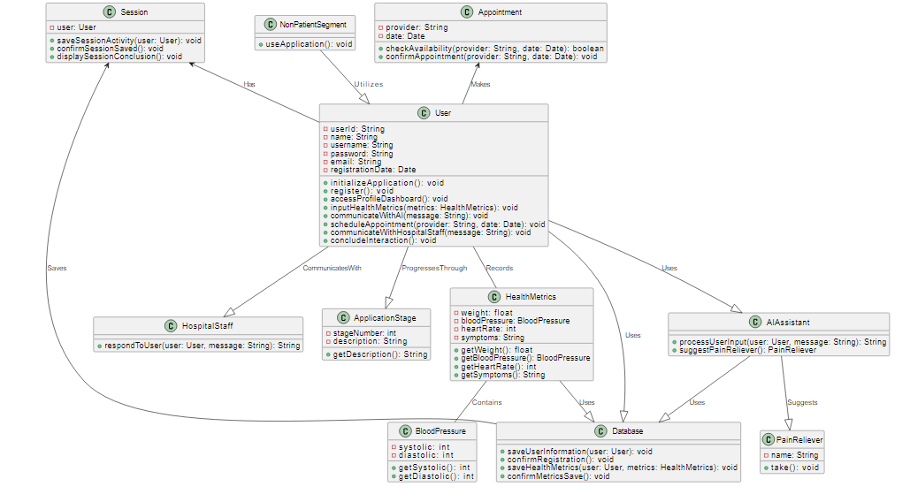

The HealthMate AI application is meticulously designed to provide a comprehensive health management solution, fostering seamless communication between users, advanced artificial intelligence, hospital staff, and a robust database. The Class Diagram illustrates the key components and their interactions within the HealthMate AI system.

**13.1. User:**

* **Attributes:**
  + **userId**: Unique identifier for each user.
  + **name**: User's full name.
  + **username**: User's chosen username.
  + **password**: User's secure password.
  + **email**: User's contact email.
  + **registrationDate**: Date of user registration.
* **Functionalities:**
  + **initializeApplication()**: Initiates the HealthMate AI application.
  + **register()**: User registration process.
  + **accessProfileDashboard()**: Accesses the user's profile dashboard.
  + **inputHealthMetrics(metrics: HealthMetrics)**: Records user health metrics.
  + **communicateWithAI(message: String)**: Engages in direct communication with the AI.
  + **scheduleAppointment(provider: String, date: Date)**: Schedule medical appointments.
  + **communicateWithHospitalStaff(message: String)**: Direct communication with hospital staff.
  + **concludeInteraction()**: Concludes user interactions.

**13.2 HealthMetrics:**

* **Attributes:**
  + **weight**: User's weight.
  + **bloodPressure**: Blood pressure metrics (instance of BloodPressure class).
  + **heartRate**: User's heart rate.
  + **symptoms**: User-reported symptoms.
* **Functionalities:**
  + **getWeight()**, **getBloodPressure()**, **getHeartRate()**, **getSymptoms()**: Retrieve individual health metrics.

**13.3 BloodPressure:**

* **Attributes:**
  + **systolic**: Systolic pressure.
  + **diastolic**: Diastolic pressure.
* **Functionalities:**
  + **getSystolic()**, **getDiastolic()**: Retrieve systolic and diastolic pressures.

**13.4 AIAssistant:**

* **Functionalities:**
  + **processUserInput(user: User, message: String)**: Processes user inputs and generates recommendations.
  + **suggestPainReliever()**:PainReliever

**13.5 HospitalStaff:**

* **Functionalities:**
  + **respondToUser(user: User, message: String)**: Responds to user inquiries and provides recommendations.

**13.6 Database:**

* + **saveUserInformation(user: User)**: Stores user information.
  + **confirmRegistration()**: Confirms user registration.
  + **saveHealthMetrics(user: User, metrics: HealthMetrics)**: Stores user health metrics.
  + **confirmMetricsSave()**: Confirms the successful save of health metrics.

**Connections:**

* The **User** class maintains associations with **HealthMetrics**, **AIAssistant**, **HospitalStaff**, and **Database**.
* **HealthMetrics** is associated with **BloodPressure**.
* **AIAssistant**, **HospitalStaff**, and **Database** collaborate to facilitate user interactions, data processing, and information storage.

**13.7 Appointment:**

**Attributes:**

* **Provider: Name**
* **Date: Date**

**Functionalities:**

**• CheckAvailability**(provider: Name, Date: date): Boolean

**• ConfirmAppointment(**procider:Name, Date: date)

**13.8 NonPatientSegment**

**Functionalities:**

**• UseAplication()**

**14. Factory method Design Pattern**

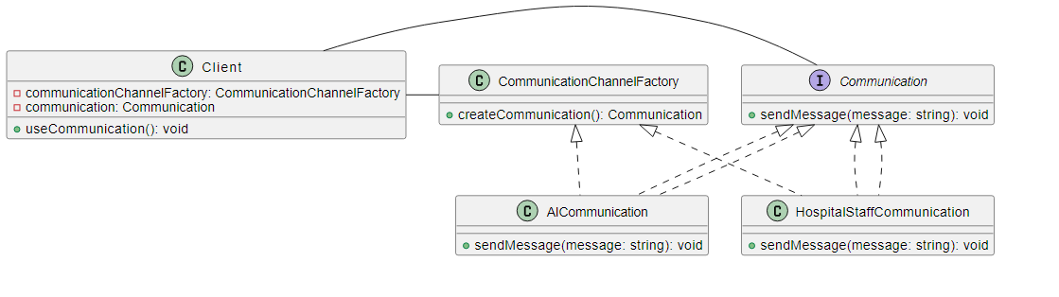

The Factory Method Design Pattern in HealthMate AI is a pivotal architectural choice that strategically manages communication channels within the healthcare application. This pattern promotes modularity, extensibility, and user experience customization.

**Elements**

**1. Communication Interface**

* **Definition:**
  + Blueprint defining the structure for communication objects.
  + Common method **sendMessage(message: string)** ensures consistency.

**2. Communication Channel Factory**

* **Role:**
  + Abstract class responsible for creating diverse communication channels.
  + Key Method: **createCommunication()** acts as the factory method.

**3. AI Communication Channel**

* **Purpose:**
  + Concrete class implementing the **Communication** interface.
  + Specialized for interactions with AI systems.

**4. Hospital Staff Communication Channel**

* **Objective:**
  + Another concrete class implementing the **Communication** interface.
  + Tailored for seamless interactions with hospital staff.

**5. AI Communication Class**

* **Functionality:**
  + Specific implementation of AI communication.
  + Executes logic for sending messages to AI based on user inputs.

**6. Hospital Staff Communication Class**

* **Functionality:**
  + Specific implementation for hospital staff communication.
  + Handles messages to hospital staff based on user inputs.

**7. Client Class**

* **Role:**
  + Represents end-users interacting with HealthMate AI.
  + Utilizes **CommunicationChannelFactory** for channel creation.
  + Manages communication channel use through dedicated methods.

**Relationships**

* **Communication Interface:** Core blueprint for all communication objects.
* **Communication Channel Factory:** Abstract class orchestrating the creation of channels.
* **Concrete Communication Classes:** Implement the interface and provide specialized functionality.
* **Client:** Leverages the factory to create and manage communication channels.

**15. Abstract Design Pattern**

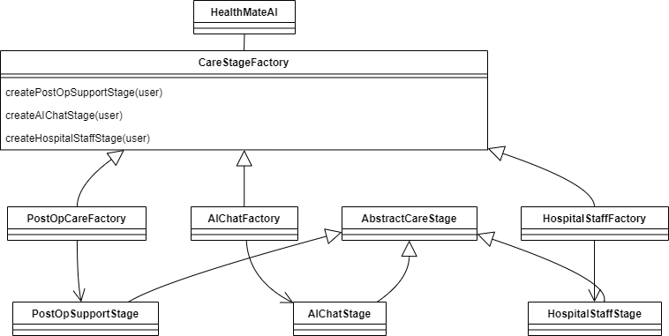

This diagram outlines the core structure of the abstract factory pattern implemented within the HealthMate AI system. It highlights the key components and their relationships, emphasizing flexibility and adaptability in object creation for different care needs.

Key Components

* Client:
  + HealthMateAI: The main application that manages user flow and utilizes the abstract factory to create appropriate care stages.
* Abstract Factory:
  + CareStageFactory: An interface responsible for generating concrete care stage instances based on user requirements.
* Concrete Factories:
  + PostOpCareFactory: Creates PostOpSupportStage instances for post-operative care.
  + AIChatFactory: Creates AIChatStage instances for AI-powered communication.
  + HospitalStaffFactory: Creates HospitalStaffStage instances for direct communication with hospital personnel.
* Abstract Products:
  + AbstractCareStage: A generic representation of a care stage, defining common features and methods.
* Concrete Products:
  + PostOpSupportStage: Provides information and support for post-operative recovery.
  + AIChatStage: Handles AI-based interactions and suggestions.
  + HospitalStaffStage: Facilitates real-time communication with hospital staff.

Relationships

* HealthMateAI interacts with the CareStageFactory to create specific CareStage instances based on user needs.
* Concrete factories inherit from the CareStageFactory, implementing its methods to generate corresponding concrete products.
* Concrete care stages inherit from the AbstractCareStage, ensuring adherence to the shared structure and behavior.

Benefits of Abstract Factory Pattern

* Flexibility: Decouples object creation from usage, enabling seamless switching between different care stages without modifying client code.
* Extensibility: Supports the addition of new care stages without affecting existing code, promoting future growth and adaptability.
* Testability: Facilitates independent testing of care stages and factories, enhancing code quality and maintainability.

The abstract factory pattern empowers HealthMate AI to dynamically adapt its functionality to diverse user needs and healthcare scenarios. This adaptable design fosters a versatile and scalable system capable of addressing evolving patient care requirements effectively.

**16. Proxy Design Pattern(Diagram of Sequence)**

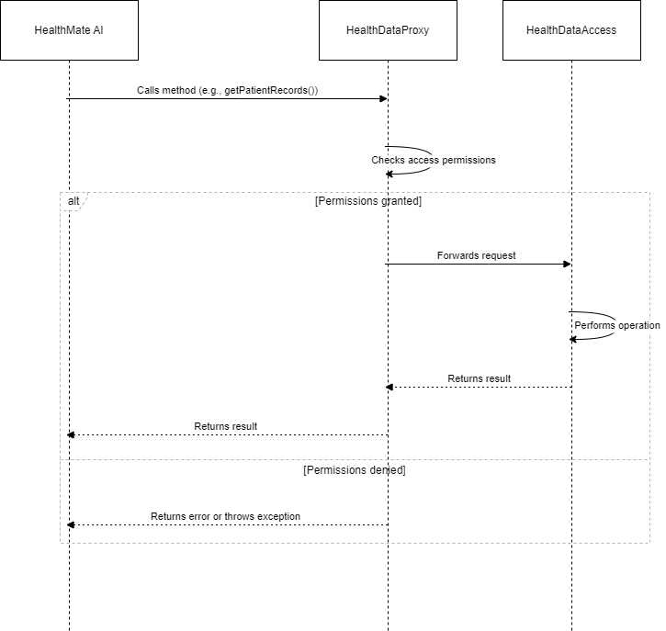

The Proxy Design Pattern plays a crucial role in HealthMate AI, ensuring secure and controlled access to health data while promoting flexibility, maintainability, and compliance.

* The Proxy Design Pattern is employed within HealthMate AI to regulate access to sensitive health data and safeguard its integrity.
* It introduces a protective layer between the HealthMate AI client and the actual health data access implementation.

Key Elements

* Client: The HealthMate AI application itself, utilizing the proxy for data interactions.
* Proxy: The HealthDataProxy class assumes the role of a controlled gateway to health data.
  + Implements the HealthDataAccess interface, mirroring the real subject's methods.
  + Acts as a gatekeeper, verifying access permissions before forwarding requests.
  + Can perform additional actions like logging, caching, or remote data access management.
* Real Subject: The HealthDataAccessImpl class encapsulates the actual data access logic.
  + Implements the HealthDataAccess interface, carrying out data retrieval or modification.
  + Remains shielded from direct client interaction.

Interactions

1. Client initiates a data request: Calls a method on the HealthDataProxy, unaware of the real subject's existence.
2. Proxy validates access: Verifies permissions before proceeding.
3. Authorized access:
   * Proxy forwards the request to the real subject for execution.
   * Real subject performs the requested operation and returns results back to the proxy.
4. Proxy handles the response:
   * May conduct post-processing or validation.
   * Returns the results to the client, maintaining transparency.
5. Unauthorized access: Proxy blocks the request, returning an error or exception.

**17. Object Diagram**

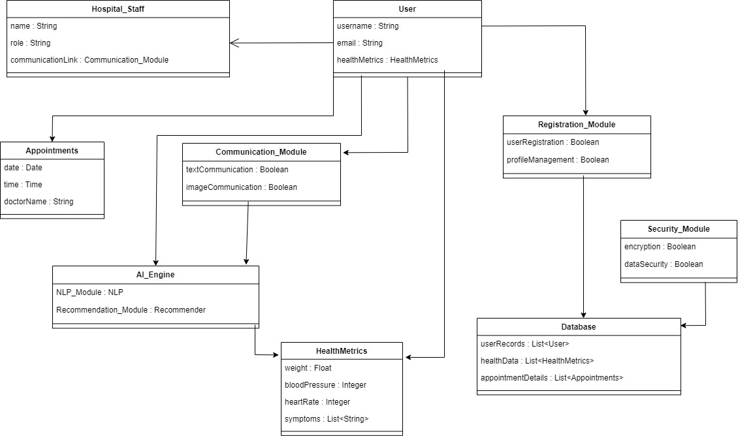

Object diagram visually represents objects, their attributes, and their relationships within a system. In this context, we'll explore the object diagram for the "User" object in HealthMate AI.

**User Object:**

* **Attributes:**
  + **username** (String): The user's chosen username during registration.
  + **email** (String): The user's email address associated with their account.
  + **healthMetrics** (HealthMetrics): An instance of the HealthMetrics class representing the user's health-related data.
* **Relationships:**
  + The User object is associated with the HealthMetrics object, which stores the user's health data.

**HealthMetrics Object:**

* **Attributes:**
  + **weight** (Float): Represents the user's weight.
  + **bloodPressure** (Integer): Stores blood pressure readings.
  + **heartRate** (Integer): Records heart rate measurements.
  + **symptoms** (List of Strings): Contains a list of user-reported symptoms.

**Appointments Object:**

* **Attributes:**
  + **date** (Date): Represents the date of a medical appointment.
  + **time** (Time): Stores the time of the appointment.
  + **doctorName** (String): Records the name of the attending doctor.

**Communication_Module Object:**

* **Attributes:**
  + **textCommunication** (Boolean): Indicates if text-based communication is supported.
  + **imageCommunication** (Boolean): Indicates if image-based communication is supported.

**Hospital_Staff Object:**

* **Attributes:**
  + **name** (String): Represents the name of a hospital staff member.
  + **role** (String): Specifies the role or job title of the staff member.
  + **communicationLink** (Communication_Module): Links to the Communication_Module object for staff communication.

**Registration_Module Object:**

* **Attributes:**
  + **userRegistration** (Boolean): Specifies if user registration is enabled.
  + **profileManagement** (Boolean): Indicates if user profile management is supported.

**Security_Module Object:**

* **Attributes:**
  + **encryption** (Boolean): Indicates if encryption features are implemented.
  + **dataSecurity** (Boolean): Specifies if data security measures are in place.

**Database Object:**

* **Attributes:**
  + **userRecords** (List of User): Stores user records.
  + **healthData** (List of HealthMetrics): Contains health-related data.
  + **appointmentDetails** (List of Appointments): Stores appointment details.

**Conclusion:**  
The object diagram for the "User" object in HealthMate AI provides a visual representation of its attributes and relationships within the system. This diagram aids in understanding how user data is structured and interacts with various components of the application.

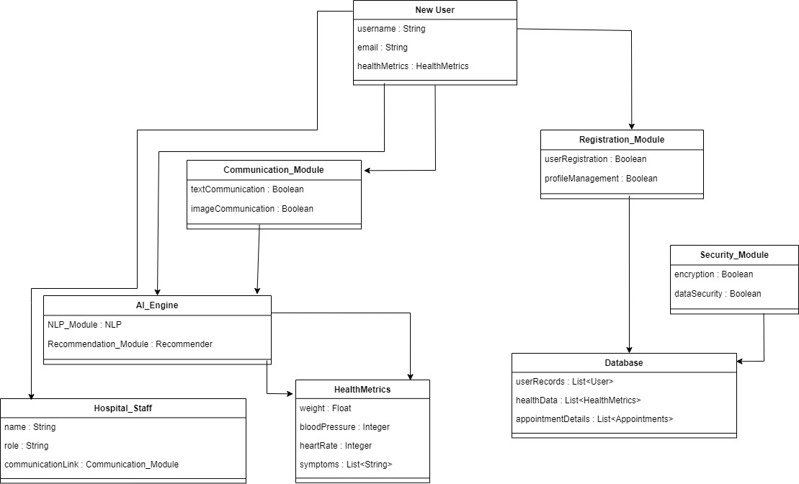

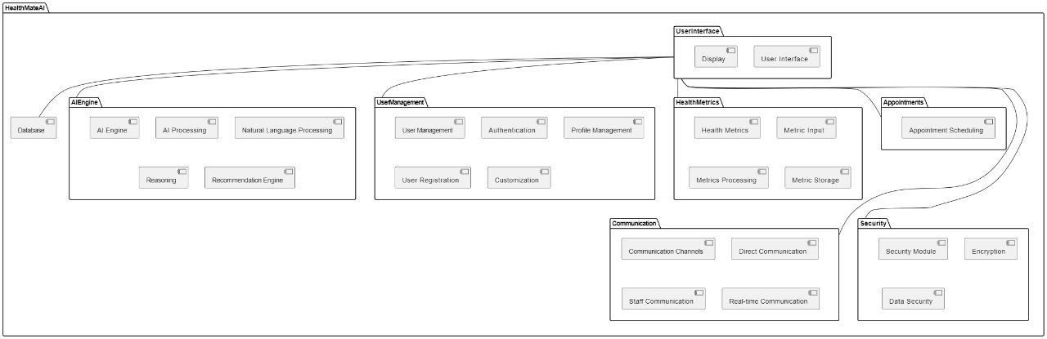

**18. Package Diagram**

The HealthMateAI package diagram illustrates the modular structure of the HealthMateAI system, showcasing various functional components and their interactions. Here's a breakdown of the key components:

1. **UserInterface:**
   * *User Interface:* Represents the graphical interface for user interaction.
   * *Display:* Handles the display of information and functionalities.
2. **AIEngine:**
   * *AI Engine:* The core component responsible for processing user input and generating recommendations.
   * *AI Processing:* Involves the overall processing capabilities of the AI.
   * *Natural Language Processing (NLP):* Handles communication through natural language.
   * *Reasoning:* Involves the logical reasoning process.
   * *Recommendation Engine:* Generates personalized recommendations.
3. **UserManagement:**
   * *User Management:* Handles user-related operations.
   * *Authentication:* Ensures secure user authentication.
   * *Profile Management:* Manages user profiles.
   * *User Registration:* Handles user registration processes.
   * *Customization:* Allows users to customize their experience.
4. **HealthMetrics:**
   * *Health Metrics:* Involves health-related data and functionalities.
   * *Metric Input:* Allows users to input health metrics.
   * *Metrics Processing:* Processes and analyzes health metrics data.
   * *Metric Storage:* Stores health metrics securely.
5. **Appointments:**
   * *Appointment Scheduling:* Facilitates the scheduling and management of appointments.
6. **Communication:**
   * *Communication Channels:* Manages various communication channels within the system.
   * *Direct Communication:* Supports direct communication between users.
   * *Staff Communication:* Enables communication with healthcare staff.
   * *Real-time Communication:* Facilitates real-time interactions.
7. **Security:**
   * *Security Module:* Ensures the security and integrity of user data.
   * *Encryption:* Implements robust encryption protocols.
   * *Data Security:* Ensures overall data security.
8. **Database:**
   * *Database:* Represents the underlying data storage.

**19. Components**

1. **User Interface (UI):**
   * **Description:** The UI component represents the graphical interface of the HealthMate AI application, allowing users to interact with the system seamlessly.
   * **Responsibilities:**
     + Displaying the various features and functionalities.
     + Providing an intuitive and user-friendly experience.
     + Supporting navigation between different sections.
2. **AI Engine:**
   * **Description:** The AI Engine is the core component responsible for processing user input, generating recommendations, and facilitating communication with users.
   * **Responsibilities:**
     + Natural Language Processing (NLP) for user communication.
     + Analyzing health metrics and generating personalized recommendations.
     + Ensuring transparency in the reasoning process.
3. **Profile Management:**
   * **Description:** The Profile Management component focuses on handling user registration, profile creation, and maintaining user-specific information.
   * **Responsibilities:**
     + User registration and authentication.
     + Managing user profiles, including personal and medical information.
     + Customizing notification preferences.
4. **Health Metrics Input:**
   * **Description:** This component enables users to input and track various health metrics, including weight, blood pressure, heart rate, and specific symptoms.
   * **Responsibilities:**
     + Providing an intuitive interface for metric input.
     + Storing and managing health metric data securely.
5. **Appointment Scheduling:**
   * **Description:** The Appointment Scheduling component facilitates users in scheduling, confirming, and managing appointments with healthcare professionals.
   * **Responsibilities:**
     + Integrating a user-friendly appointment scheduling system.
     + Sending reminders and managing appointment history.
6. **Hospital Staff Communication:**
   * **Description:** This component ensures direct communication channels between users and hospital staff, offering timely and personalized medical advice.
   * **Responsibilities:**
     + Enabling real-time communication.
     + Escalating user queries to hospital staff when needed.
7. **Segment for Individuals:**
   * **Description:** This component addresses the segment for individuals who are not current patients, offering fee-based access to various health-related features.
   * **Responsibilities:**
     + Managing access permissions for different user segments.
     + Providing additional health-related services.
8. **Security Module:**
   * **Description:** The Security Module is responsible for ensuring the confidentiality and integrity of user data.
   * **Responsibilities:**
     + Implementing robust encryption protocols.
     + Conducting regular security audits and vulnerability assessments.

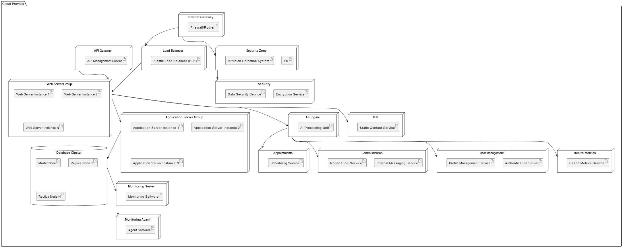**20. Deployement Diagram**

The deployment diagram for HealthMate AI illustrates the system's physical architecture within a cloud-hosted environment. The main components and their interactions are described as follows:

* **Cloud Provider**: Represents the cloud infrastructure that hosts the HealthMate AI application. The cloud may be a platform such as AWS, Azure, or Google Cloud, which provides scalability and high availability.
* **Internet Gateway**: Acts as the entry point for all external traffic, enabling secure user access to the HealthMate AI system through the internet. It is protected by a Firewall/Router that ensures secure data transfer.
* **Load Balancer**: Utilizes Elastic Load Balancing (ELB) technology to distribute incoming traffic evenly across the Web Server Group. This balances the load and ensures optimal performance and reliability.
* **Web Server Group**: Contains multiple instances of web servers that serve the application's user interface and API endpoints. These instances handle incoming requests and manage sessions and dynamic content.
* **Application Server Group**: If utilized, this group of application servers manages the application logic. It may also employ internal load balancing to manage the distribution of tasks.
* **Database Cluster**: A resilient database cluster with master and replica nodes stores user profiles, health metrics, and appointment details. It ensures data integrity and availability even in failover scenarios.
* **Monitoring Server**: Oversees the health and performance of the system with specialized Monitoring Software. It collects and analyzes metrics from all nodes and components.
* **Security Zone**: A specialized network area that houses critical and sensitive components, like the database and security services, to ensure data isolation and protection.
* **AI Engine**: The core intelligence of HealthMate AI, which includes an AI Processing Unit responsible for analyzing user input, generating recommendations, and managing user interactions.
* **User Management**: Manages user-related functionalities such as authentication, profile management, and user registration.
* **Health Metrics**: Dedicated to managing the collection, processing, and storage of health-related data such as weight, blood pressure, heart rate, and symptoms.
* **Appointments**: Handles the scheduling and management of appointments with healthcare providers via a Scheduling Service.
* **Communication**: Ensures effective communication through internal messaging for staff and external notification services for users.
* **Security**: Encompasses various services aimed at protecting the system, including Encryption Service for data protection and Data Security Service for safeguarding against threats.
* **API Gateway**: Manages external API access and serves as a routing mechanism for third-party services to interact with the HealthMate AI's functionalities.
* **CDN**: A Content Delivery Network used to efficiently serve static content to users, which helps reduce latency and improve user experience.
* **WAF**: An optional Web Application Firewall that protects the web servers from various cyber threats and attacks.
* **Monitoring Agent**: Software installed on each node that collects data for the Monitoring Server, contributing to a comprehensive view of system health.

Each of these components plays a crucial role in the deployment of HealthMate AI, ensuring that the application is secure, efficient, and resilient.